**Dynamics of *Teleaulax* cryptophyte prey during red water blooms**

**in the Columbia River Estuary**

*Authors:*

Maria Hamilton 1,2, Gwenn M. Hennon 1, Joseph Needoba 3, Katie Maxey 3, Rhonda Morales 1, Tawnya D. Peterson 3, Megan Schatz 1, Jarred Swalwell 1, Peter Zuber 3, E. Virginia Armbrust 1, Francois Ribalet 1*

*Affiliations:*

1 School of Oceanography, University of Washington, Box 357940, Seattle, WA 98195 USA

2 Present address: Ocean Sciences Department, UC Santa Cruz, 1156 High Street, Santa Cruz, CA 95064

3 Institute of Environmental Health, Oregon Health & Science University, 3181 SW Sam Jackson Park Rd., Portland, OR 97239 USA

* Corresponding author: ribalet@uw.edu

**ABSTRACT (250 words max)**

The mixotrophic *Mesodinium major* is a globally distributed nontoxic ciliate that produces red-colored blooms using chloroplasts from its cryptophyte prey, *Teleaulax amphioxeia.* Little is known about the physiology of *T. amphioxeia* and how it influences the development of *M. major* blooms. To better understand how environmental factors influence the dynamics of *T. amphioxeia*, a 4-week survey was conducted in the Columbia River Estuary, OR, USA in 2013 during which abundances and division rates of the cryptophytes were continuously monitored using flow-cytometry. The highest abundance of free-living *T. amphioxeia* occurred during the first neap tide with concentrations as high as 1.8 x 106 cells L-1 and decreased during spring tide and later neap tides (< 0.5 x 106 cells L-1). A 10-fold variation in cell abundance occurred daily, which was not correlated with daily tidal cycle or spring/neap tide cycle. Division rates ranged from 0.2 to 1.5 d-1, with the highest values observed in accordance with high abundances of *T. amphioxeia,* and were positively correlated with concentrations of dissolved inorganic nitrogen and phosphorus. A strong coupling was observed between the availability of *T. amphioxeia* and the abundance of *M. major*, suggesting that the amount of prey limited the abundance of the ciliate. Our results highlight the importance of free-living *T. amphioxeia* for the development of red water blooms in the Columbia River Estuary.

Key words: cryptophytes; *Teleaulax; Mesodinium;* growth rates.

**INTRODUCTION**

The common coastal ciliate, *Mesodinium major*, previously referred to as *Mesodinium rubrum* (=*Myrionecta rubra*) (Lohmann 1908, Jankowski 1976), is among the marine microzooplankton that temporarily maintains the plastids of their cryptophyte algal prey, *Teleaulax amphioexa* (Herfort et al. 2011b). This association allows the ciliate to function as a mixotroph, capable of utilizing both phagotrophy and photosynthesis to acquire carbon (Crawford 1989). Mixotrophic *M. major* populationsare now understood to be important primary producers in coastal and estuarine systems (Stoecker et al. 1989, Herfort et al. 2012). However, little is known about the ecology and physiology of the *T. amphioexa* prey and how their growth impacts the bloom dynamics of *M. major*.

Massive *M. major* blooms occur each year in the Columbia River Estuary (CRE) and last for several months during the late summer and early fall (Herfort et al. 2011a), which shifts the estuary from net heterotrophy to net autotrophy (Herfort et al. 2012). The annual *M. major* bloom appears to be initiated during summer neap tides (Herfort et al. 2011a) when both tidal forcing and the seasonality of freshwater discharge result in an extended summer saltwater intrusion (Chawla et al. 2008) and a temporary decrease in turbulence. The bloom commonly starts in Baker Bay, where a shallow depth and high retention favor high cell abundances (>100 cells mL-1) and fast growth rates (1.2-3.1 d-1) of *M. major*. Within a few weeks, this initial bloom spreads throughout the main estuary (Herfort et al. 2011a). A decline in the abundance of small (<5 µm), free-living *Teleaulax* cells coincided with an increase in *M. major* abundance observed in the CRE in 2011 (Peterson et al. 2013), suggesting a direct link between consumption of the cryptophyte prey and the initiation of an *M. major* bloom. In an Antarctic saline lake, however, an increase in the abundance of cryptophytes preceded the increase in abundance of *M. rubrum* (van den Hoff et al. 2015). Thus, the underlying mechanisms remain unclear for the observed correlations between the abundance of free-living cryptophyte prey and the development of *M. major* blooms.

At least part of this complication comes from the numerous factors that influence cell abundances, including cell division, cell mortality and physical transport. In a dynamic system such as the CRE, a continuous sampling approach must be applied in order to capture changes in abundances over time. In addition, continuous measurements of the size structure can be used to estimate division rates based on changes in cell size distribution over the course of a day (Sosik et al. 2003, Hunter-Cevera et al. 2014, Ribalet et al. 2015). This new method eliminates many of the difficulties and biases associated with the determination of cell division rates using discrete sampling techniques (Laws 2012).

Here, we apply a continuous approach to the study of cryptophyte abundance and division rates both in the laboratory and in the field using the continuous flow cytometer, SeaFlow (Swalwell et al. 2011). We determined how abundances and division rates of the *T. amphioexa* are affected by environmental conditions, and how it influences, in turn, the abundances of *M. major.* To do so, a 4-week survey was conducted in 2013 during which dissolved nutrients, salinity, temperature, light irradiance, and abundances of cryptophytes and *M. major* were measured during red water blooms in the CRE. Daily division rates of cryptophytes were calculated from the change of size distribution over a 24-h period using the size-structured division rate model (Sosik et al. 2003).

**METHODS**

**Study Area**

Samples were collected at 2.4 m depth for 1 month, 4 days a week, from September 11th to October 2nd 2013 using a continuous seawater flow-through system of SATURN03, a fixed station located at the end of a dock in Hammond, OR (**fig. 1**) (Batista et al. 2015). Most discrete samples were collected during the turn of the high tide (i.e., at slack water).

**Hydrological conditions**

Water temperature, salinity and pH were measured continuously at SATURN-03 using a SeaBird <model> Conductivity-Temperature (CT) meter for temperature and salinity, and a Durafet pH sensor (Honeywell). Photosynthetic Active Radiation (PAR) data were obtained from Desdemona Sands Light mooring, located 3 km north of SATURN-03.

**Nutrient concentrations**

30 mL water samples for nutrient analysis were taken in duplicate.

JN writes this

**Determination ofcryptophyte cell abundance**

Continuous measurements of cryptophyte abundances and cell size were made using SeaFlow, (Swalwell et al. 2011). The instrument was equipped with a 457-nm 300-mW laser (Melles Griot). Forward light scatter (a proxy for cell size), red and orange fluorescence were collected using a 457–50 bandpass filter, 572–27 bandpass filter, and 692–40 band-pass filter, respectively. Seawater was prefiltered through a 100-µm stainless steel mesh (to eliminate large particles) prior to analysis. The flow rate of the water stream was set at 15 mL min−1 through a 200-µm nozzle for the field and laboratory experiments; this corresponded to an analysis rate of 15 µL min−1 by the instrument (Swalwell et al., 2011). A programmable syringe pump (Cavro XP3000, Hamilton Company) continuously injected fluorescent microspheres (1 µm, Polysciences) into the water stream as an internal standard. Data files were created every three minutes. Data were analyzed using the R package *Popcycle* version 0.2, which uses a SQLite relational database management system to retrieve flow cytometry data (<https://github.com/uwescience/popcycle>). A sequential bivariate manual gating scheme was used to cluster cryptophyte population based on orange fluorescence and forward light scatter measurements.

For the identification of cryptophytes cells, discrete samples for flow cytometry samples were collected once a day during slack tide, fixed with 0.025% glutaraldehyde and stored at -80 ºC. Six months after sample collection, fixed samples were analyzed with a BD Influx cell sorter. 100 cells from the gated population of high-orange particles (assumed to represent phycoerythrin-containing cryptophytescells) were sorted onto a glass slide. The cells were then examined under a Nikon Eclipse 80i epifluorescence microscope at 400x magnification and photographed using a Qimaging MicroPublisher 3.3 RTV camera.

**Estimates of cryptophyte cell division rates**

We used a size-structured matrix population model developed by Sosik et al. (2003) to estimate cryptophyte population division rates. We implemented Sosik’s original Matlab model in an R package *ssPopModel* version 0.1.1, available on Github (<https://github.com/armbrustlab/ssPopModel>). The model is based on the assumptions that 1) cell growth is determined by light exposure, with other abiotic factors such as nutrient availability and temperature operating at longer time scales, 2) the probability of a cell dividing depends on size, 3) all cells within a discrete size class have the same probability to change to another size class, and 4) a cell divides into two daughter cells, each half the size of the mother cell. The model predicts the cell size distribution over the course of the day using the cell size/cell division relationships and the light-dependence of cell division.

*Estimated division rates in cultures.*

A non-axenic culture of the cryptophyte *Rhodomonas* sp. (CCMP 755) was grown in the laboratory in natural seawater amended with f/2 nutrients at 13 °C with a 16:8 light-dark cycle of 100 µE m-2 s-1 provided by white fluorescent tubes. The culture was grown for 4 days in a 20-L batch culture and mixed with a magnetic carboy stir bar and analyzed with SeaFlow. On day 3, 1 mL samples of the culture were collected in triplicate every 2 hours for 28 hours, fixed with 0.01% glutaraldehyde and stored in liquid nitrogen. One month after sample collection, fixed samples were stained with 0.01% green-fluorescing DNA stain SYBR Green I (diluted with dimethylsulfoxide) for 15 minutes at room temperature in the dark. Following the addition of fluorescent microspheres (1 μm, Polysciences) used as internal standard, stained samples were analyzed with a BD Influx flow cytometer. Data were obtained using the *Spigot Operating Software* version 5.0 (BD Biosciences) and analyzed using *FlowJo* version 9.7.2 (Tree Star). A minimum of 10,000 cells werecollected per sample. DNA frequency distributions were analyzed using *FlowJo* cell cycle platform to obtain cell fractions in G1, S, and G2+M phases. Division rates based on DNA distributions were computed as described previously (Carpenter and Chang, 1988).

*Estimated division rates in the field.*

The method used to estimatehourly division rates of *Rhodomonas* sp*.* in culture was applied to cryptophyte populations in the field. Daily-averaged division rates were calculated as the sum of hourly division rates over a 24-h period.

**Cryptophyte community composition**

*DNA extraction*

Sample volumes of 0.5-2.0 L were filtered with a 20 μm filter followed by a 0.2 μm Sterivex filter. The size fractionation was performed to separate the *Teleaulax* symbiont in *M. major* cells from free living *Teleaulax.* Filters were fixed with 2 mL of RNAlater and stored at -80°C until extraction.

Samples were extracted using the CTAB method (Li et al. XXXX). Briefly, the filters are suspended in buffer and proteinase K in 2 ml microcentrifuge tubes and incubated at 55°C overnight. After this incubation, 165 μL each of 5M NaCl and 10% CTAB were added and incubated for an additional 10 min at 55°C. Approximately 600 μL of chloroform was added and the samples were then vortexed for 75 seconds, followed by centrifugation (13,000g) for 10 min. The DNA of the aqueous layer was purified using a DNA Clean and Concentrate Kit (Zymo Research). The total extracts were stored at -20°C until further use.

*Identification of the cryptophyte nuclear 28S D2 element*

A specific genetic marker was used to distinguish between *T. amphioxeia* and other free-living cryptophytes. This marker is the Unique Sequence Element (USE) found in the D2 region of the LSU rRNA sequence. The cryptophyte nuclear D2 region of the LSU was identified using the 28S D1-D5 sequence for the cryptophyte *Goniomonas truncata* (accession number FJ176709). A BLASTn search showed a large gap in sequence homology of around 300-400 bp near the 5’ end of the LSU. Primers were designed using Primer-BLAST to flank this gap region (crp28SF CTTGCTTGGGAATGCAGGTC /crp28SR TACGAGCCTCCACCAGAGTT). These primers were used with PCR to identify the LSU D2 of *Teleaulax*.Single cell PCR was performed on *M. major* cells from red water in the CRE collected in 2011 and 2014. The lab culture of the Antarctic strain of *M. rubrum* (CCMP2563) was used as a control, as it is fed with the cryptophyte *Geminigera cryophilia* (CCMP 2564)*.* The PCR protocol for the LSU D2 sequence identification is as follows: initial denaturation at 95°C for 3 min; 35 cycles of denaturation at 95°C for 45 sec, annealing at 50°C for 40 sec, and extension at 70°C for 2 min; and a final extension at 70°C for 7 min. The results of the PCR were visualized on a 1% agarose gel. The PCR products were purified (UltraClean PCR clean up kit, MoBio), ligated into a TOPO 2.1 vector (Invitrogen), and transformed into chemically competent *E. coli* cells (DH5α strain). The transformed cells were grown up overnight at 37°C on LB plates containing 40 μg mL-1 X-gal and 50 μg mL-1 Kanamycin. White colonies were selected and grown up overnight in a 37°C water bath shaker in 2X YT broth with 50 μg mL-1 Kanamycin. Miniprep (FastPlasmid Mini Kit, 5 Prime) was performed and the samples were sent to the Molecular and Cellular Biology Core of the ONPRC for sequencing. Sequences of around 650 bp were assembled and aligned using *Geneious* software version XXX.

Alignment between the *T. amphioxeia* and *G. cryophilia* D2 sequences identified a unique sequence element (USE) (Kahn et al. XXX) of around 220 bp. The *T. amphioxeia* USE was used as a species specific marker to track the free-living cryptophyte and *M. major* in the estuary. The specificity of the USE was demonstrated using FISH on red water and lab culture samples. A FISH probe labeled with the fluorophore Alexa488 [TxD2 FISH (Alexa 488 – AACACACGAGTTAAGATACCAATGGATCATTCACTCGCATGCCC)] was designed to hybridize to the 3’ end of the USE in *T. amphioxeia*. The probe was labeled with Alexa488 fluorophore. The probe was seen in the cytoplasm of both the ciliate and free cryptophytes in red water samples, but not in the laboratory *M. rubrum* culture.

The 28S D2 sequence was extended to the 3’ end of the 18S rRNA using the general eukaryotic 18S primer BMB-CR (GTACACACCGCCCGTCG)to Crp28SR. This region includes the 5S and ITS2. The 18S rRNA sequence generated was identical to that of *T. amphioxeia*.

*Real Time PCR*

The distribution and size of the cryptophyte and specific prey population was monitored in environmental samples by qPCR. Analysis was performed on a StepOnePlus Real Time PCR system (Life Technologies) using SYBR Green as the reporter dye and the following protocol: initial denaturation at 95 °C for 10 min; 40 cycles of denaturation at 95°C for 15 s, and extension and data acquisition at 60 °C for 1 min; followed by a melting curve analysis. The *T. amphioxeia* specific primers [TxD2 1F (TGAAAAAGGGCCTGAAATTG) /TxD2 USE 2R (ATCATTCACTCGCATGCCCC)] were used to amplify the USE of the prey cryptophyte. General cryptophyte primers [CrpSpecf 3F (GTTCTGAAGATGCTGGCACA)/ CrpSpecf 3R (GTTCTGAAGATGCTGGCACA)] were used to monitor total cryptophyte populations and calculate the ratio of prey to total cryptophytes. This sequence was downstream of the USE. Primers were designed using Primer-BLAST from NCBI and confirmed with PCR.

The Antarctic *M. rubrum* culture was used as a control (i.e., negative for prey-specific and positive for general-cryptophyte sequences). All environmental total extracts were diluted 10-fold before analysis to remove interfering compounds. All standards, samples and water blanks were analyzed in triplicate and 1 μL of DNA template was used in each reaction. Standards for qPCR were constructed with the *T. amphioxeia* LSU D2 region cloned into a TOPO 2.1 vector. This plasmid was used for both primer sets as it contained the *T. amphioxeia* specific USE and general cryptophyte sequences. A standard curve was generated from six standards with concentrations ranging from 9.289 x 106 – 9.289 x 101 D2 copies µL-1. Concentrations of the standards were calculated from Kahn et al. (XXXX). Concentrations of USE copies were determined with the following formula:

Copies/mL = abc/d

Where *a* is the copies μL-1 determined from qPCR, *b* is the volume in μL the extracted DNA was re-suspended in, *c* is the dilution factor and *d* is the volume in mL of the water sample.

***Mesodinium major* cell abundance**

45 mL samples fixed with 0.5% glutaraldehyde were collected into 50 mL centrifuge tubes for *M. major* counts and stored at -20 °C pending analysis. Prior to analysis, the samples were slowly thawed to 4 oC and analyzed using an imaging flow cytometer (FlowCAM, Fluid Imaging, Inc.). A minimum of 1000 particles with diameter >5 m were captured and the images were filtered using *VisualSpreadsheets* software version XX (Fluid Imaging, Inc.) according to size. Those resembling *M. major* were selected based on visual inspection and enumerated. Flow rates were calculated using *VisualSpreadsheets* software, allowing for the quantification of cellular abundances.

**RESULTS**

**Environmental conditions**

The Columbia River Estuary is a turbid and often highly stratified system characterized by its dynamic physical processes, short residence time (0.5-5 days), and strong influence from diurnal and semi-diurnal tides (Neal 1972, Jay 1984). Throughout the 4-week survey at SATURN03 (**Fig. S1**), surface water temperature and salinity were anti-correlated and oscillated with the tidal cycle, with high tide characterized by an influx of colder seawater, and low tide characterized by an increase of warmer freshwater. The survey began and ended during neap tides (day 1-4, day 15-25). The spring tide, which occurred during the second week of the survey (day 7-11), coincided with the highest surface water salinity and lowest temperature observed during the survey. The lowest salinity was observed on the last neap tide (day 23-25), with little variation in temperature over the tidal cycle (**Fig. 1A**). The average surface water temperature and salinity during the survey was 17.5 °C and 12 psu, respectively.

The variations of pH were correlated with tidal cycles, with values increasing during flood tides that ranged from 7.8 to 8.4 (**Fig. 1B**). The lowest pH values were observed at day 3 and increased progressively later on. Concentrations of dissolved inorganic phosphate (DIP) and nitrogen (DIN as the sum of nitrate, nitrite and ammonium) were relatively high during the survey (> 5 µM and > 0.4 µM for DIN and DIP, respectively), with the highest values observed at day 7, which coincided with the start of the spring tide. DIP and DIN concentrations co-varied throughout the survey (**Fig. 1C**) and were negatively correlated with pH (R2 = 0.47 and 0.34, p< 0.05, respectively) (**Fig. S2**).

Total chlorophyll *a* fluorescence, a proxy of phytoplankton biomass, was low during neap tides (week 1, 3 and 4) , and increased to its highest values during spring tide (week 3) (**Fig. 1B**). A positive correlation between fluorescence and tidal cycle was observed during the survey (R2 = 0.34, p < 0.001), with high values increasing during flood tide.

**Cell abundances**

The small size (<5 µm in length) and teardrop shape of the cryptophyte cell population sorted with the flow cytometer and observed under light microscope (**Fig. 2**) agreed with past observations of *Teleaulax amphioexa* cells (Peterson et al. 2013). We therefore assumed that the cryptophyte cell population measured by the SeaFlow represented a *T. amphioexa* population during the survey.

Hourly-averaged cell abundances of *T. amphioxeia* measured ranged from 0.02 x 106 to 1.8 x 106 cells L-1, with an average of 0.29 x 106 cells L-1 (**Fig. 3**). Cell abundances obtained with the SeaFlow were in excellent agreement with discrete samples analyzed by conventional flow cytometry (R2 = 0.83, p < 0.01, **Fig. S3**). The highest abundances of *T. amphioxeia* were observed during the first two days of the first neap tide, with a daily-averaged abundance of 0.52 x 106 cells L-1, (**Fig. 3A**). The spring tide (day 7-10) and second neap tide (day 15-18) exhibited the lowest abundances, with an average of 0.08 x 106 cells L-1 and 0.09 x 106 cells L-1, respectively (**Fig. 3B and C**). Although variations in cell abundance occurred within individual days, changes in cell abundance did not coincide with daily tidal cycle or spring/neap tide cycle. No significant correlation was observed between *T. amphioxeia* cell abundances and salinity (data not shown).

The abundances of *T. amphioxeia* were comparable to the abundances of *M. major* at high-tide, with values varying from 0.021 x 106 to 0.32 x 106 cells L-¹ during the survey (**Fig. 3**). A positive correlation between abundances of *T. amphioxeia* and *M. major* was observed during the survey (R2 = 0.24, p < 0.01) (**Fig. S4**). Except at day 10, abundances of *M. major* were lower than those of *T. amphioexa*. Abundances of *M. major* during the survey were not significantly correlated with environmental conditions such as salinity, nutrient concentrations or spring/neap tide cycle (data not shown).

The percent of *T. amphioexa* to the total cryptophytes was always less than 1% (0.06% to 0.40%; **Table 1**), with the highest and lowest percents of *T. amphioexa* occurring during the first and second week of the survey, respectively, similar to the cell abundances of *T. amphioxeia* and *M. major* (**Fig. 3**).

**Division rates**

To establish the accuracy of size distribution-based division rate estimates using SeaFlow measurements of forward-angle light scattering converted to cell volume using an empirical relationship (Ribalet et al. 2015), we compared size-based estimates of division rates (h-1) with cell-cycle based estimates of division rates for the cryptophyte *Rhodomonas*. The hourly division rates estimated using both cell cycle analysis and the model followed the same general trend throughout the experiment (**Fig.** **4**), although some discrepancies occurred around dawn (at hour 1, 3 and 27). The coefficient of determination R2 = 0.60 (p < 0.001) (**Fig.** **S5**) indicates that the model provides reasonable estimates of division rate for the cryptophyte *Rhodomonas* in culture*.* In the field, our limited access to the sampling site prevented the use the cell-cycle method to validate our model-based estimates of division rates for *T. amphioxeia*. During the entire survey, the size distribution of *T. amphioxeia* increased during daylight and decrease at night (**Fig.** **5A**), which is consistent with the model assumptions that photosynthesis and cell division are the main factors influencing the change of cell volume over a 24-h period (Sosik et al. 2003). No effect of the tidal cycle was observed on the cryptophyte size distribution, suggesting that the size structure *T. amphioxeia* population was not affected by the tide.

Estimates of the daily division rates of *T. amphioxeia* during the survey ranged from 0.2 ± 0.1 d-1 to 1.5 ± 0.1 d-1 (**Fig. 5**), which correspond to 0.3 and 2.1 division per day, respectively. The highest division rate was observed at day 3 and coincided with the lowest pH values (**Fig. 2C**). Division rates were positively correlated with concentrations of dissolved inorganic nutrients (R2 = 0.44 and 0.30, p < 0.05, for DIP and DI, respectively) and negatively correlated with pH during the survey (R2 = 0.41, p < 0.05) (**Fig. S6**), with decreasing division rates observed with daily-averaged pH > 8.0. No significant correlation was observed between division rates and other environmental factors, such as temperature (data not shown).

**DISCUSSION**

**Ecophysiology of the *Teleaulax amphioexa*** **during the survey**

The cryptophyte *Teleaulax amphioexa* is a marine species distributed in coastal habitats worldwide. During our survey, no consistent increase in *T. amphioxeia* cell abundance was observed with seawater intrusion, and variations in abundances were not directly related to the daily tidal cycle or spring/neap tide cycle. The lack of a relationship between *T. amphioxeia* cell abundance and salinity is in direct contrast with our measurements of red fluorescence, which suggested that seawater intrusions bring many phytoplankton cells of marine origin, such as *M. major* (REF), into the estuary. *T. amphioxeia* only makes up for less than 1% of the total cryptophytes contributing little to the total phytoplankton biomass in the estuary. Abundances of *T. amphioxeia* can shift dramatically over the course of just a few hours. These results suggest that *T. amphioxeia* distribution is very patchy within the CRE, and highlight the importance of physical transport in the dynamics of *T. amphioxeia* in the estuary. Such variability in cell abundance should be taken into consideration when interpreting results from abundance data extrapolated from a small number of data points, and emphasizes the importance of continuous measurements for monitoring phytoplankton in the CRE.

To the best of our knowledge, this study is the first to attempt to estimate division rates of cryptophyte species in the field. These estimates are based on a size structured model that made several assumptions in order to estimate division. One assumption is that cells can only grow via photosynthesis and not by other processes, such as phagotrophy. While the photosynthesis-dependent cell growth holds for the cryptophyte *Rhodomonas* grown under laboratory conditions (**Fig. S5**), we were not able to verify this assumption in the filed. However, increase in cell volume in *T. amphioxeia* population was only observed during daylight while decrease in cell volume was only observed at night, consistent with the model assumptions that cell growth and cell division are the main factor driving the changes of the size structure over a diel cycle.

The highest estimates of *T. amphioxeia* division rates reached 1.5 d-1 during the survey (day 3), which is consistent with *T. amphioxeia* isolates grown in the laboratory under nutrient replete conditions (Nishitani et al. 2008, Berge et al. 2010, Rial et al. 2012), suggesting that cells at that time were growing near optimal growth conditions. Lower division rates of *T. amphioxeia* during the survey were correlated with pH value lower than 8. The negative effect of pH on the division rates of *T. amphioxeia* was unexpected considering that a previous study showed that their growth was only affected by pH values < 6.1, with no significant effect at pH > 8.0 (Berge et al. 2010). One parsimonious hypothesis for this apparent discrepancy could be that nutrient availability was depleted in surface waters at low pH (< 8) limiting the growth *T. amphioxeia* during the survey, while nutrient concentrations remained in excess under culture conditions despite reduced nutrient solubility. The potential effect of nutrient availability on *T. amphioxeia* growth is unexpected in the turbid waters of the Columbia River Estuary, where light is generally considered to be an important factor limiting phytoplankton growth (Small et al. 1990). No significant correlation between irradiance and *T. amphioxeia* division rates was observed during the survey, which support previous studies that hypothesized that the photosynthetic machinery of cryptophytes is well adapted to low-light conditions (Bergman et al. 2004).

**Impact of *Teleaulax* cryptophyte on *M. major* abundances during the survey**

The abundances of *T. amphioxeia* were comparable to those of *M. major*. Assuming ingestion rates between ~3.5 and 8.9 cryptophytes ciliate-¹ day-¹ by *M. major* (Yih et al. 2004, Hansen and Fenchel 2006), our results would indicate that abundances of free-living *T. amphioxeia* were limiting the abundance of *M. major*. The positive correlation between the abundances of *T. amphioxeia* and *M. major* supports this hypothesis. Using a FISH probe for the *T. amphioexa* 28S DNA, up to >20 *T. amphioexa* cells were observed within or attached to a single *M. major* cell (P. Zuber, unpublished data). This finding supports previous observations of *M. major* having the ability to retain cryptophytes during red water blooms in the CRE (Peterson et al. 2013). While the ability of *T. amphioexa* to divide inside *M. major* has not yet been demonstrated in cultures, it has been observed in other single-celled endosymbiont-bearing organisms, such as the ciliate *Paramecium bursaria* (Kodama and Fujishima 2009, Johnson 2011). However, without a cultured representative of *M. major*, the fate of *T. amphioexa*, either as a whole endosymbiont or as sequestered organelles, inside the ciliate remain speculative. Future studies would benefit from the combined use of molecular methodologies and high-resolution sampling to examine the interactions between the captured cryptophyte prey and its ciliate predator, *in situ*.

**Acknowledgments**

All the SeaFlow fans without whom life would be meaningless.

CMOPers, Michael Wilkins and co.

**References**

Baptista AM, Seaton C, Wilkin MP, Riseman SF, Needoba JA, Maier D, Turner PJ et al. (2015) Infrastructure for collaborative science and societal applications in the Columbia River estuary. Frontiers of Earth Science 9:659-682

Berge T, Daugbjerg N, Andersen BB, Hansen PJ (2010) Effect of lowered pH on marine phytoplankton growth rates. Marine Ecology Progress Series 416:79-91

Bergman T, Fahnenstiel G, Lohrenz S, Millie D, Schofield O (2004) The impacts of a recurrent resuspension event and variable phytoplankton community composition on remote sensing reflectance. Journal of Geophysical Research 109: 1–12

Carpenter E, Chang J (1988) Species-specific phytoplankton growth rates via diel DNA synthesis cycles. I. Concept of the method. Marine Ecology Progress Series 43:105-111

Chawla A, Jay D, Baptista J, Wilkin, Seaton (2008) Seasonal variability and estuary-shelf interactions in circulation dynamics of the river-dominated estuary. Estuaries and Coast 31:269-288

Crawford D (1989) *Mesodinium rubrum*: the phytoplankter that wasnʼt . Marine Ecology Progress Series 58:161-174

Hansen PJ, Fenchel T (2006) The bloom-forming ciliate *Mesodinium rubrum* harbours a single permanent endosymbiont. Marine Biology Research *2*:169-177

Herfort L, Peterson TD, Campbell V, Futrell S, Zuber P (2011) *Myrionecta rubra* (*Mesodinium rubrum*) bloom initiation in the Columbia River estuary. Estuarine, Coastal and Shelf Science 95:440-446

Herfort L, Peterson TD, McCue LA, Crump BC, Prahl FG, Baptista AM, Campbell V, Warnick R, Selby M, Roegner GC, Zuber P (2011) *Myrionecta rubra* population genetic diversity and its cryptophyte chloroplast specificity in recurrent red tides in the Columbia River estuary. Aquatic Microbial Ecology 62:85-97

Herfort L, Peterson TD, Prahl FG, McCue LA, Needoba JA, Crump BC, Roegner GC, Campbell V, Zuber P (2012) Red Waters of *Myrionecta rubra* are Biogeochemical Hotspots for the Columbia River Estuary with Impacts on Primary/Secondary Productions and Nutrient Cycles. Estuaries and Coasts 35:878-891

Hunter-Cevera KR, Neubert MG, Solow AR, Olson RJ, Shalapyonok A, Sosik HM (2014) Diel size distributions reveal seasonal growth dynamics of a coastal phytoplankter. PNAS 111(27): 9852–9857

Jay DA (1984) Circulatory processes in the Columbia River Estuary. Columbia River Estuary Study Taskforce, Astoria, OR

Johnson MD (2011) The acquisition of phototrophy: adaptive strategies of hosting endosymbionts and organelles. Photosynthetic Research 107:117-132

Kahn et al.

Kodama Y, Fujishima M (2009) Timing of perialgal vacuole membrane differentiation from digestive vacuole membrane in infection of symbiotic algae Chlorella vulgaris of the ciliate Paramecium bursaria. Protist 160:65–74

Laws 2012

Li et al.

Lohmann H (1908) Untersuchungen zur Feststellung des vollstandigen Gehaltes des Meeres an Plankton. Wiss. Meeresunters. 10: 129-370

Neal VT (1972) Physical aspects of the Columbia River and its estuary. In: Pruter AT, Alverson DL (eds) The Columbia River estuary and adjacent ocean waters. University of Washington Press, Seattle, WA, p 19–40

Nishitani G, Nagai S, Takano Y, Sakiyama S, Baba K et al (2008) Growth characteristics and phylogenetic analysis of the marine dinoflagellate Dinophysis infundibulus (Dinophyceae). Aquat Microb Ecol 52:209–221

Peterson TD, Golda RL, Garcia ML, Li B, Maier MA, Needoba JA, Zuber P (2013) Associations between *Mesodinium rubrum* and cryptophyte algae in the Columbia River estuary. Aquatic Microbial Ecology 68:117-130

Rial P, Garrido JL, Jaén D, Rodríguez F (2013) Pigment composition in three Dinophysis species (Dinophyceae) and the associated cultures of Mesodinium rubrum and Teleaulax amphioxeia. Journal of Plankton Research35:433-437

Ribalet F, Swalwell J, Clayton S, Jiménez V, Sudek S, Lin Y, Johnson ZI, Worden AZ, Armbrust EV (2015) Light-driven synchrony of Prochlorococcus growth and mortality in the subtropical Pacific gyre. PNAS 112:8008-8112

Small (1990)

Sosik HM, Olson RJ, Neubert MG, Shalapyonok A (2003) Growth rates of coastal phytoplankton from time-series measurements with a submersible flow cytometer. Limnology and Oceanography 48:1756-1765

Stoecker DK, et al. (1989) Abundance of autotrophic, mixotrophic, and heterotrophic planktonic ciliates in shelf and slope waters. Marine Ecology Progress Series 50:241-254

Swalwell JE, Ribalet F, Armbrust EV (2011) SeaFlow: A novel underway flow-cytometer for continuous observations of phytoplankton in the ocean. Limnology and Oceanography: Methods 9:466-477

van den Hoff J, Bell, E (2015) The ciliate Mesodinium rubrum and its cryptophyte prey in Antarctic aquatic environments. Polar Biology 38:1305-1310

Yih W, Kim HS, Jeong HJ, Myung G, Kim YG (2004) Ingestion of cryptophyte cells by the marine photosynthetic ciliate Mesodinium rubrum. Aquat Microb Ecol 36: 165−170

**Table**

**Table 1.** Percent of *Teleaulax amphioxeia* to the total cryptophytes during the survey. Perhaps add a column to show total cryptophyte abundances?

|  |  |
| --- | --- |
| Date | % *T. amphioexa* to total cryptophytes |
| 9/11/13 | 0.40 |
| 9/13/13 | 0.18 |
| 9/20/13 | 0.06 |
| 9/24/13 | 0.08 |
| 10/1/13 | 0.23 |

**Figures**

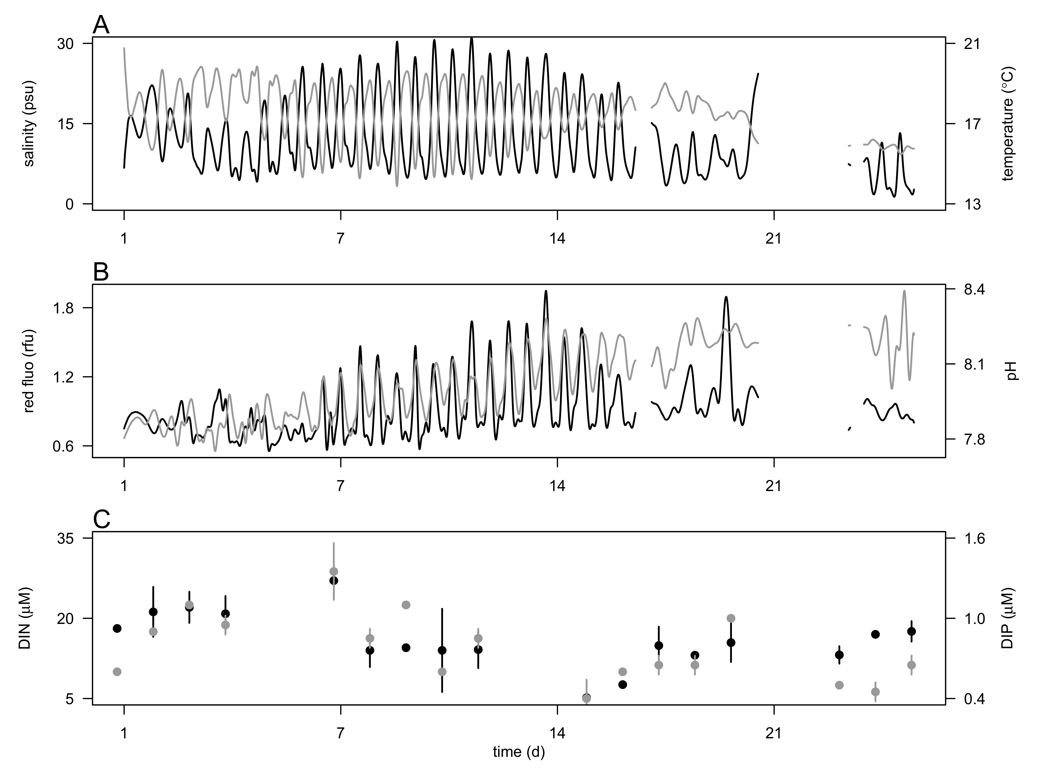

**Fig. 1** Hydrological conditions during the 4 week-survey in the CRE at 2.4 m depth. A) Salinity (psu, black line) and temperature (ºC, grey line). Red fluorescence (black line, relative fluorescence unit, rfu and pH (grey line), and C) concentrations of dissolved inorganic nitrogen (DIN, µM, open circle) and phosphorus (DIP, µM, black circle). Vertical bars represent the ranges of the mean nutrient concentration.

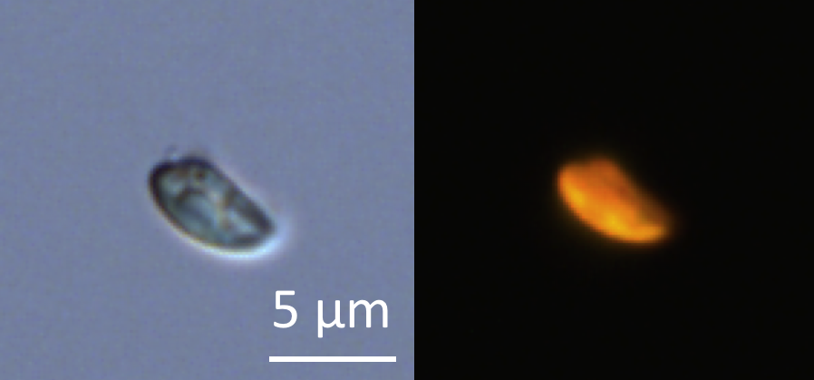

**Fig. 2.** Micrograph of glutaraldehyde-fixed *Teleaulax amphioxeia* cells using transmitted-light (A) and epifluorescence (B) microscopy after cell sorting by flow cytometry. Scale bar is 5 µm.

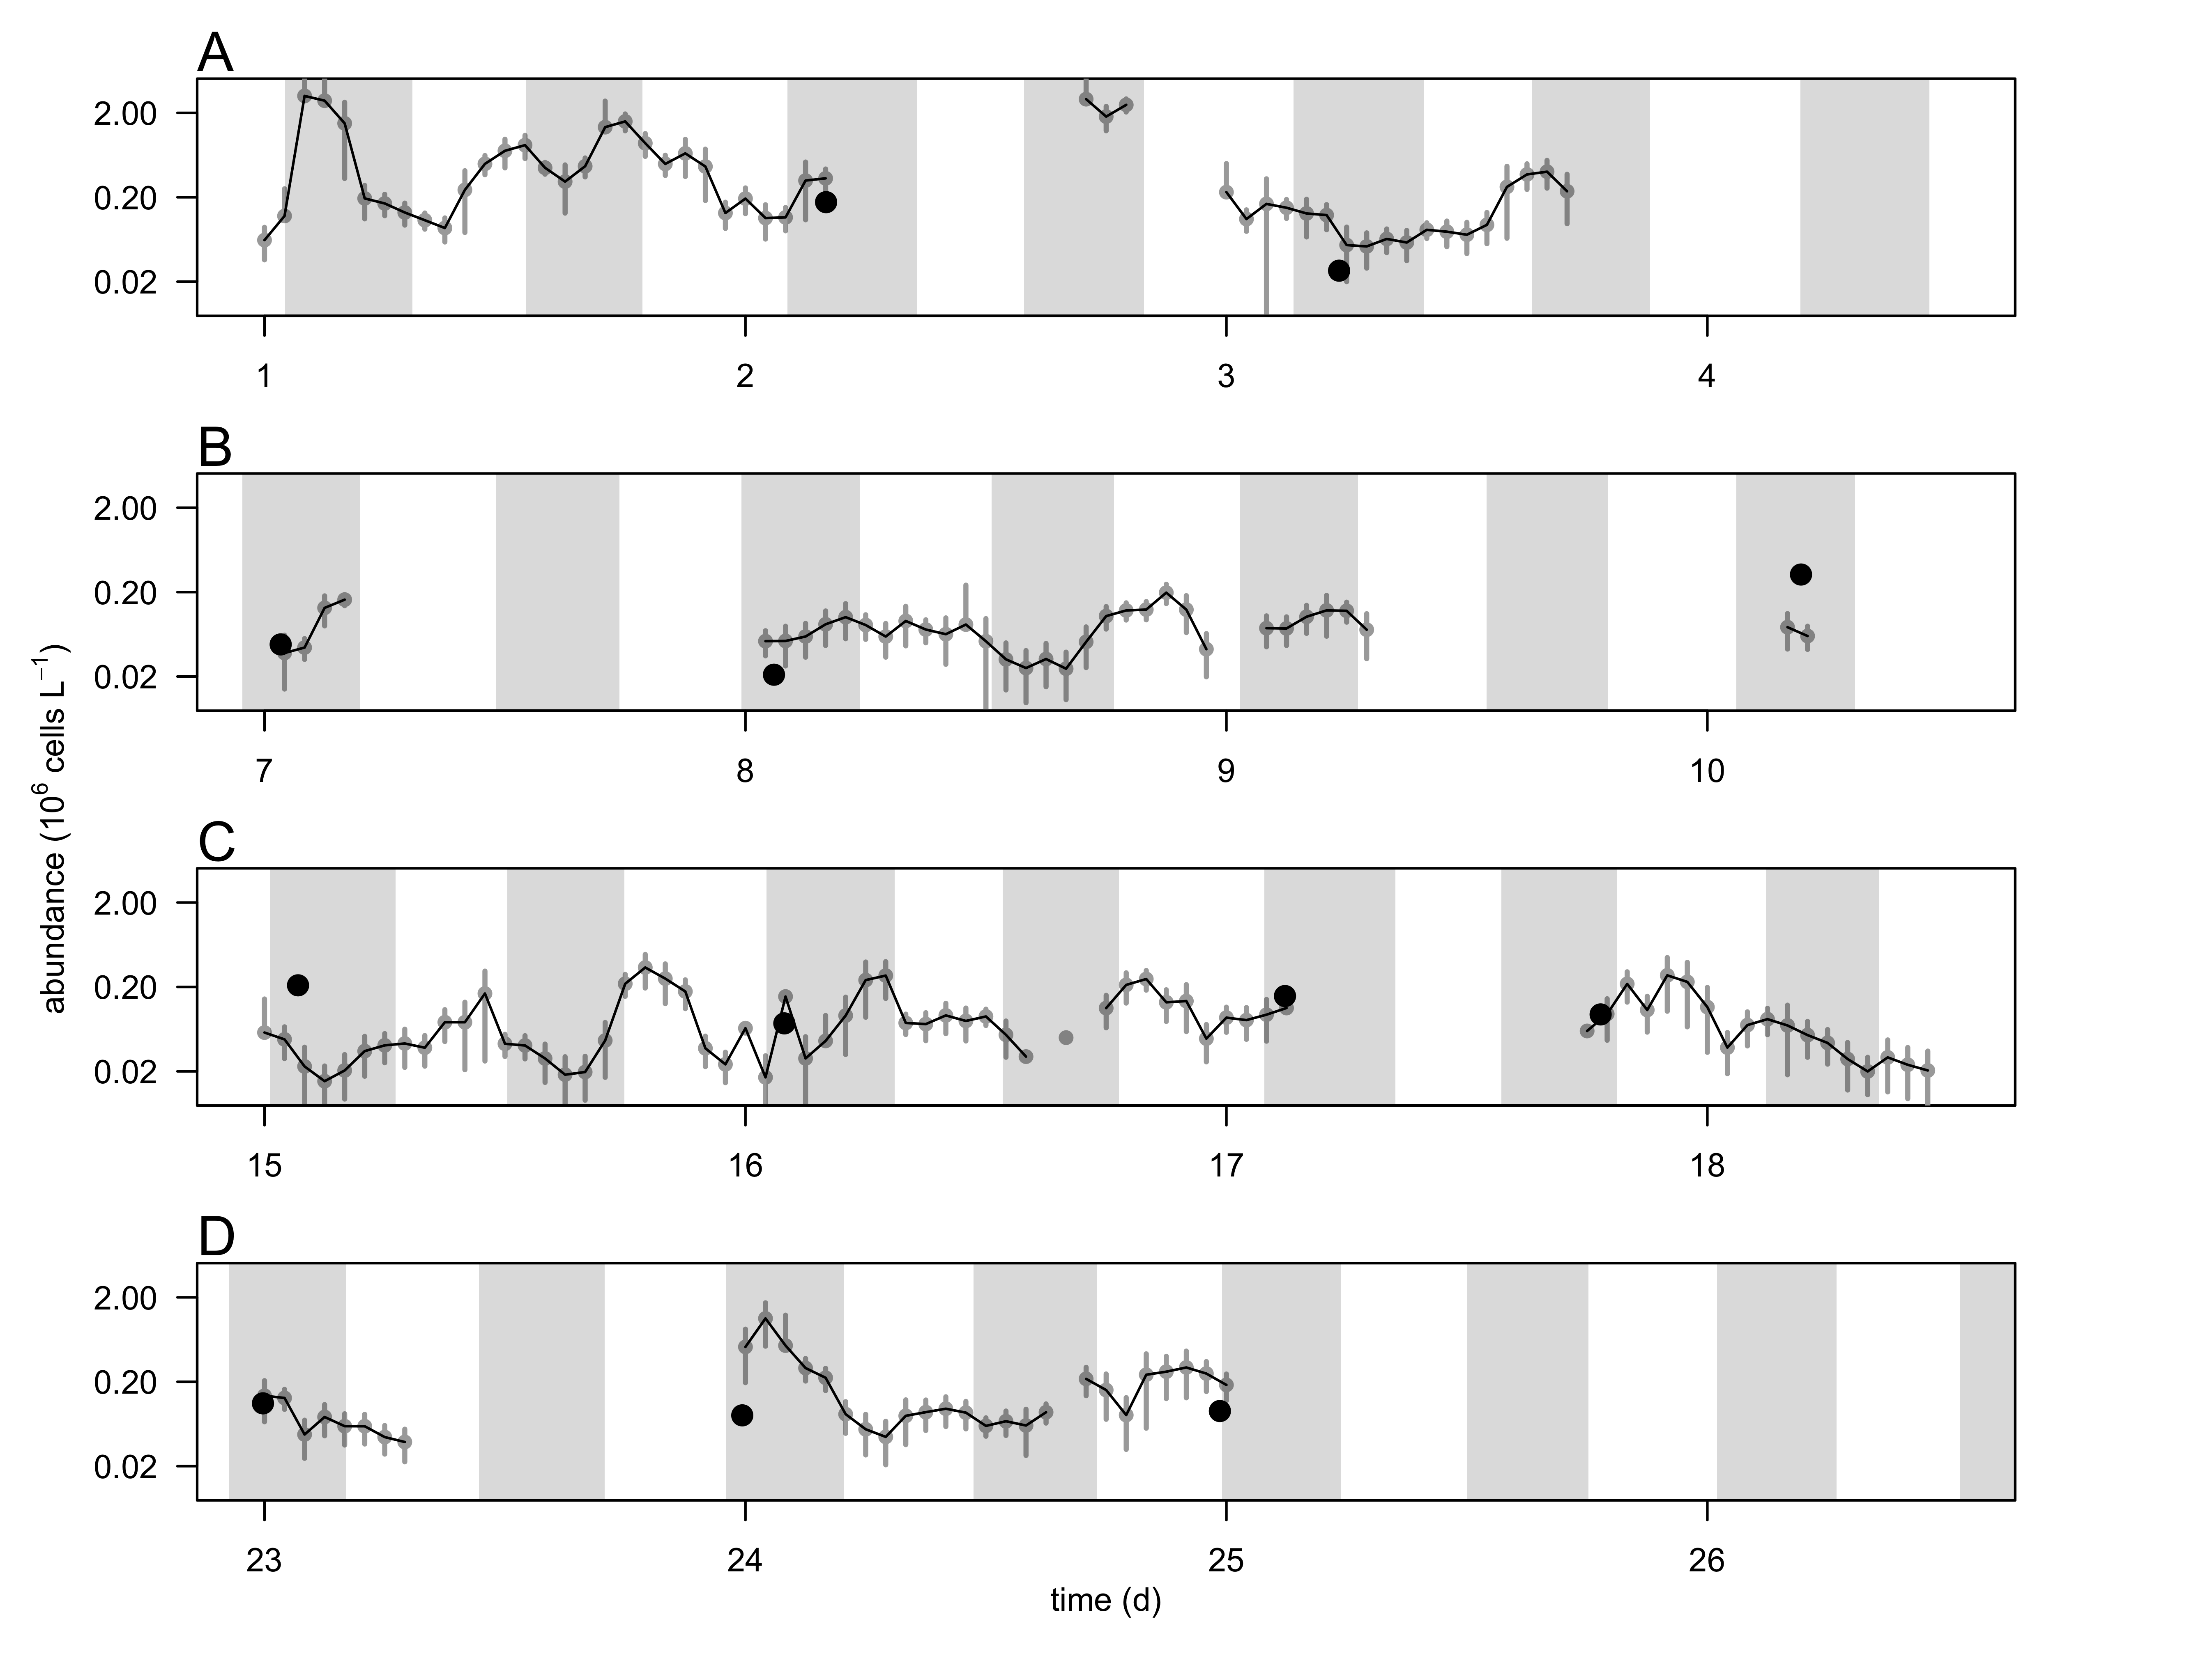

**Fig. 3** Hourly-averaged cell abundances of *Teleaulax amphioxeia* (grey circles and black line, 106 cells L-1) and abundance of *Mesodinium major* (black circles, 106 cells L-1) during the 4-week survey in the CRE (A-D). Vertical bars represent the standard deviation of the hourly-mean cell abundance (n=20). Grey regions represent flood tide. The discontinuity of the *T. amphioxeia* cell abundance is the result of frequent clogging of the flow cytometer due to high concentrations of suspended particle in the water.

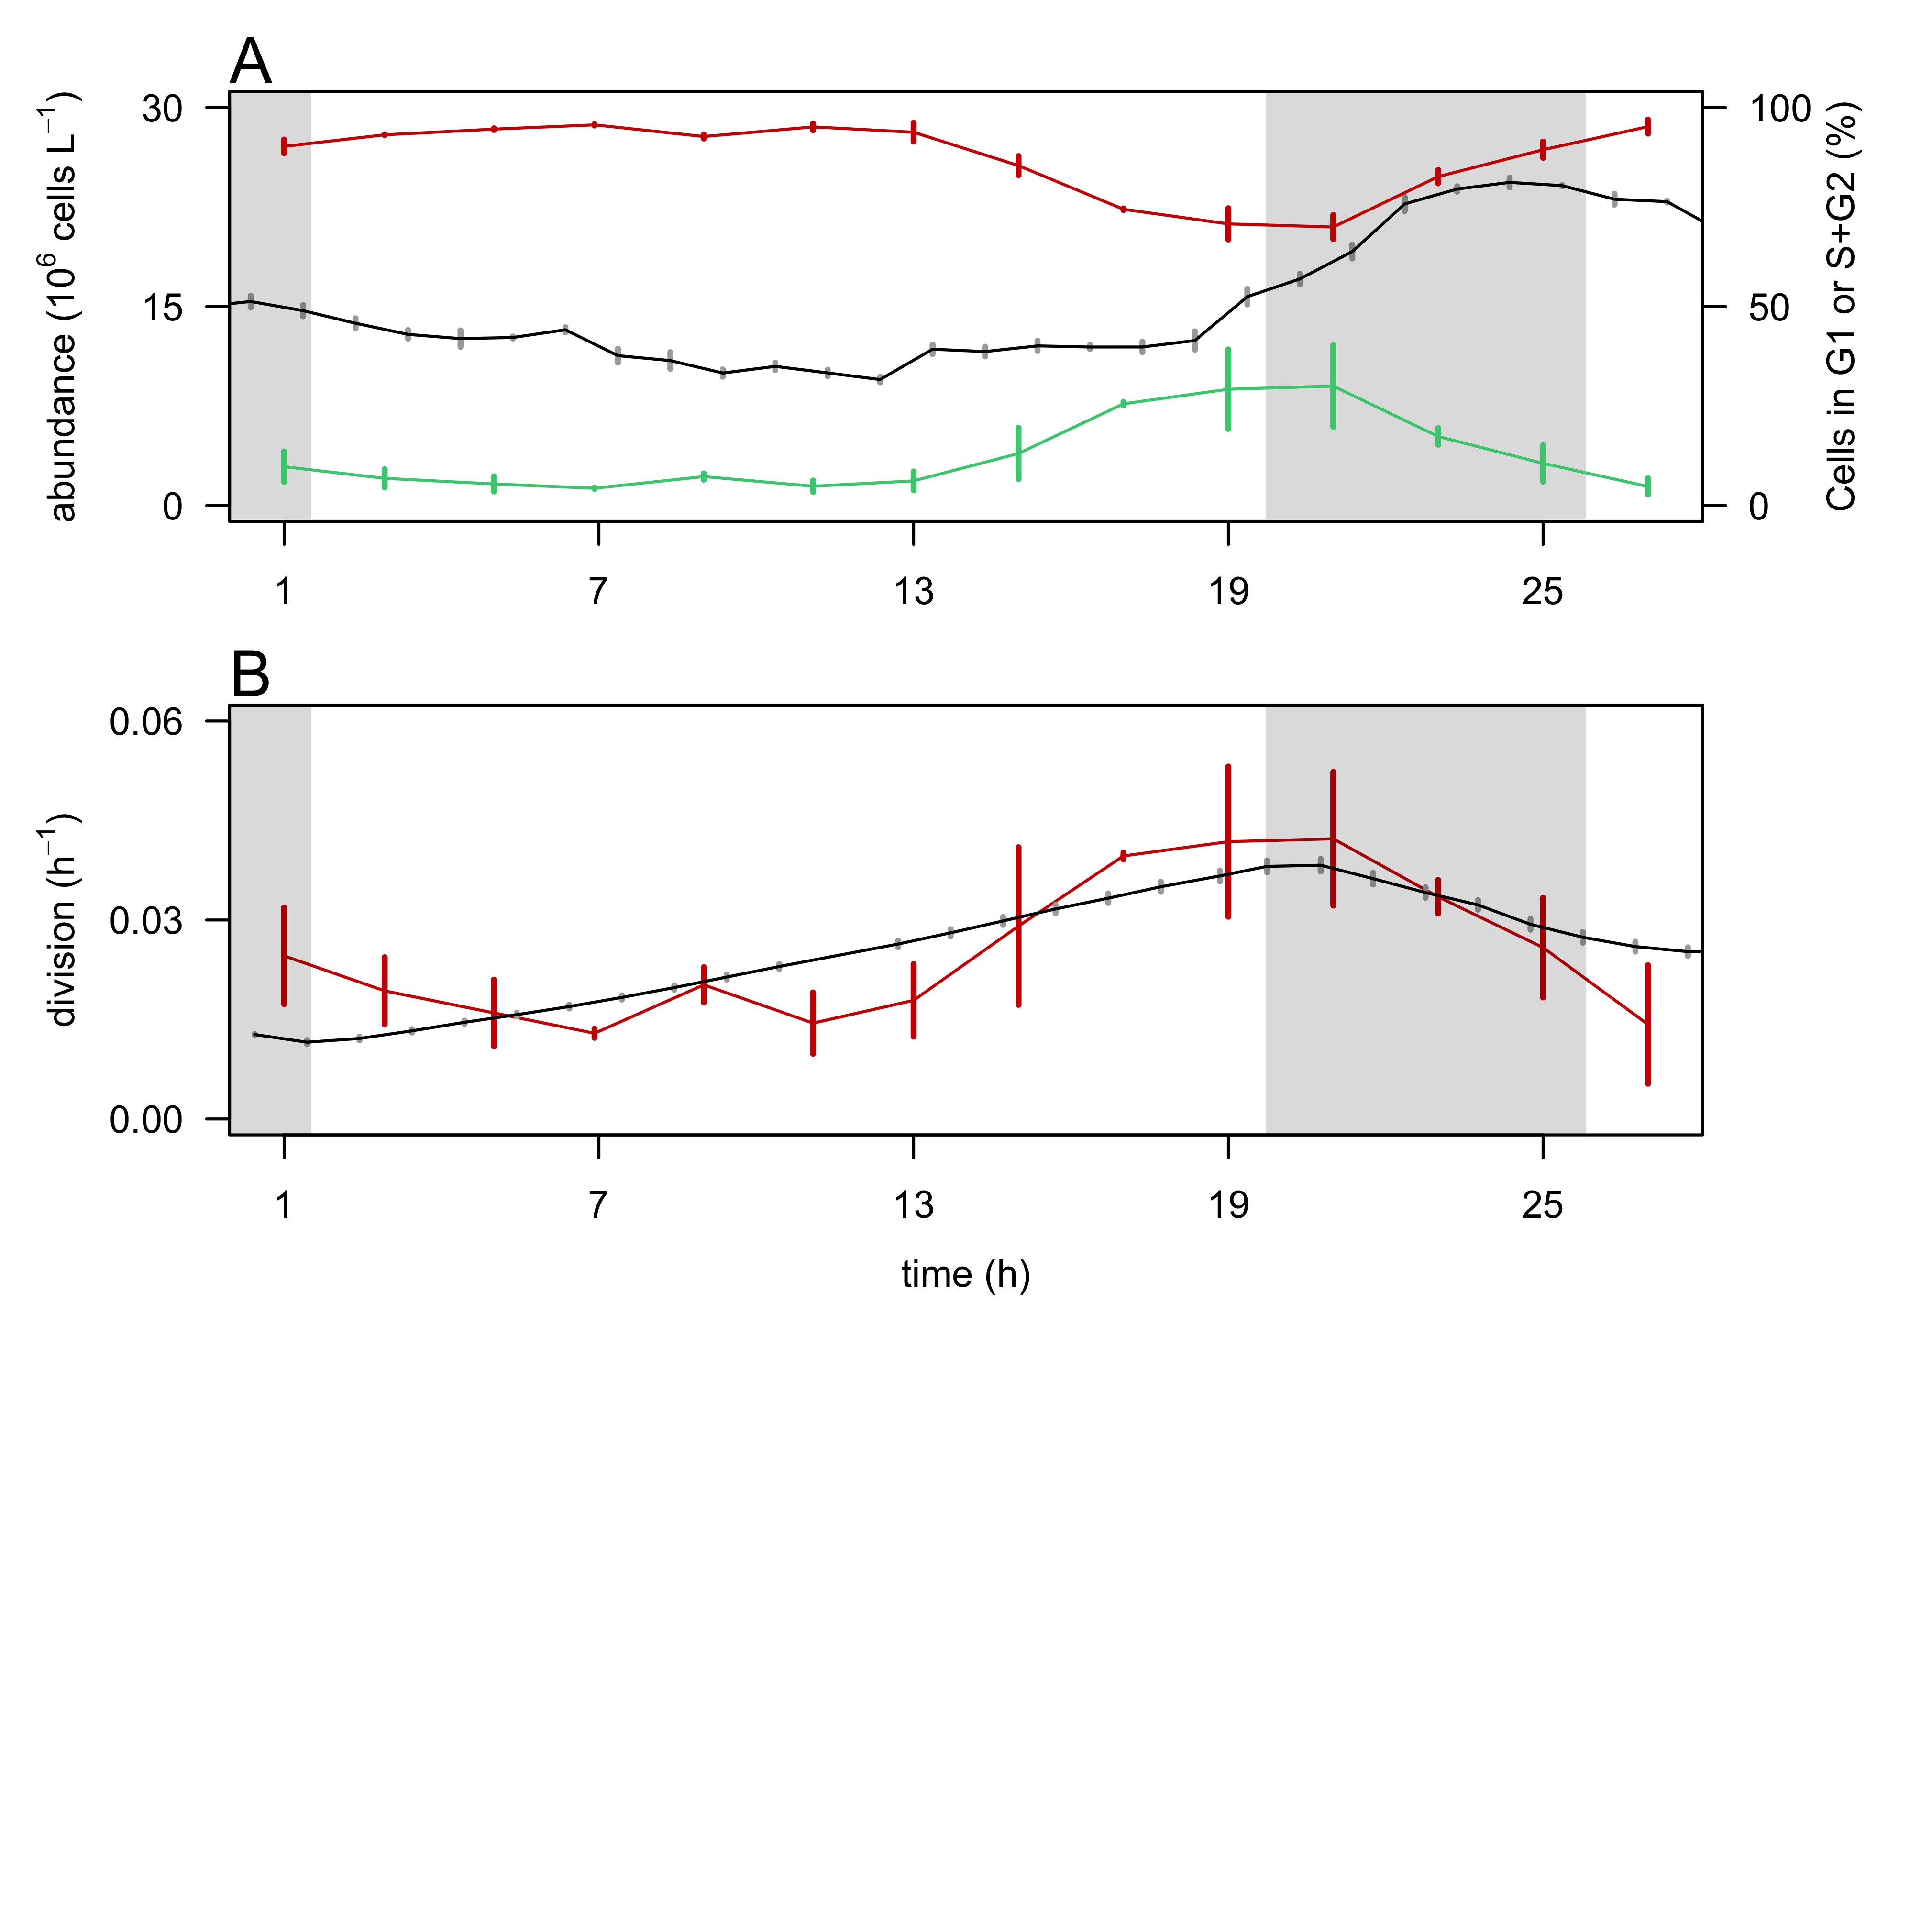

**Fig. 4.** Validation of the size-based division rate model with a cultured cryptophyte isolate during a 28-hr experiment.A) Hourly- averaged cell abundances of *Rhodomonas sp.* (106 cells L-1, black line) and percentage of cells in G1 (red line), and S+G2 (green line) phases. B) Hourly division rates (h-1) based on the relative proportions of cells in S+G2 phases (red line) and based on the size distribution (black line). The grey regions indicate night. Vertical bars represent standard deviations (n=20 for abundances, n=3 for the percent of cells in G1 and S+G2 phases, n=24 for the size-based division rates).

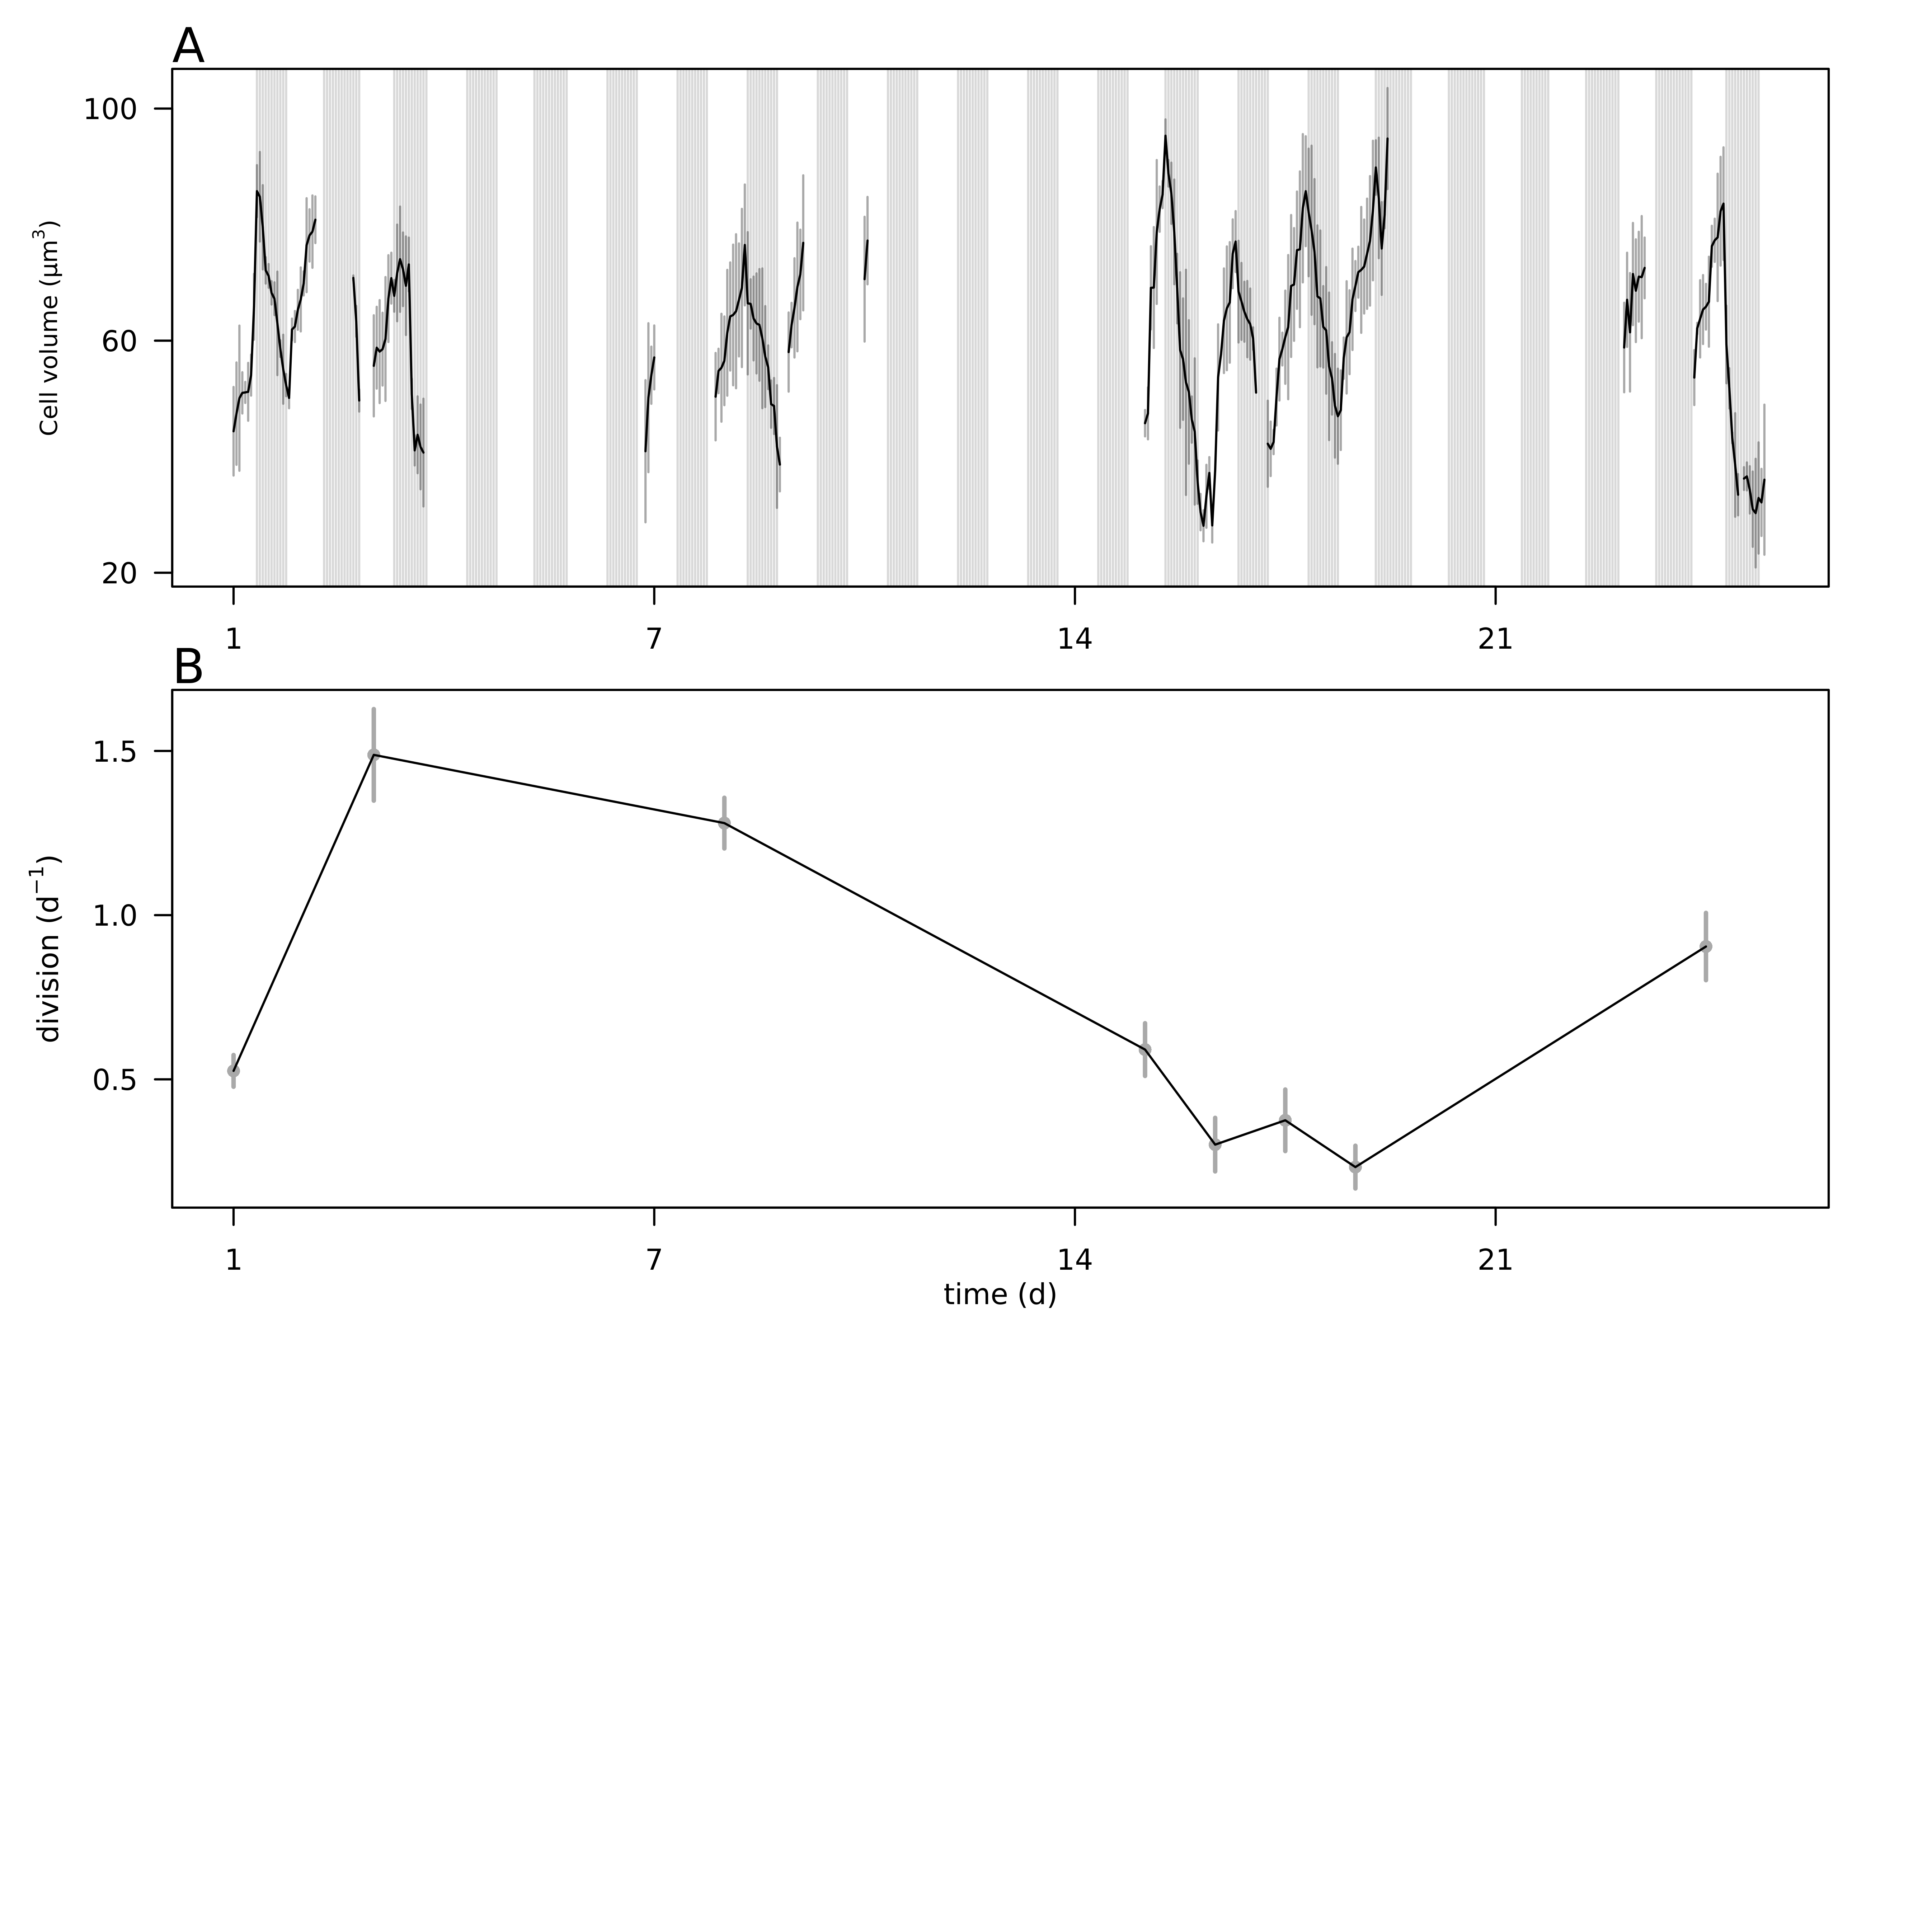

**Fig. 5.** A) Hourly-averaged cell volumes of *Teleaulax amphioxeia* (µm3) estimated by SeaFlow during the survey. Vertical grey bars represent the standard deviation of the hourly-mean cell volume. The grey regions indicate night. B) Daily rates of cell division (d-1) of *Teleaulax amphioxeia* during the survey in the CRE. Vertical bars represent the propagated standard error of the sum of hourly division rate estimates during each of the ten 24 h-period.

*The following supplement accompanies the article*

**Dynamics of *Teleaulax* cryptophytes during red water blooms in the Columbia River Estuary**

**Maria Hamilton, Joseph Nedoba, Katie Maxey, Rhonda Morales, Tawnya Peterson, Megan Schatz, Jarred Swalwell, Peter Zuber, E. Virginia Armbrust, Francois Ribalet \***

* Corresponding author: [ribalet@uw.edu](mailto:ribalet@uw.edu)

*Marine Ecology Progress Series XXX: XX–XX (201X)*

**Supplement.**

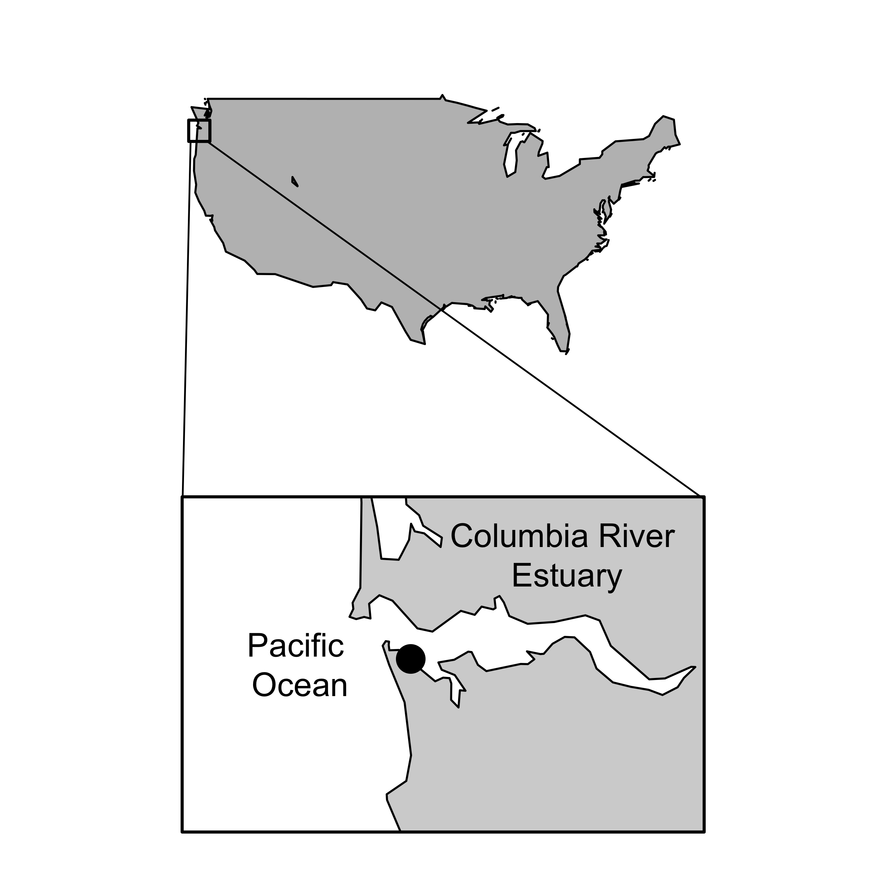

**Fig. S1** Map of the Columbia River Estuary with the sampling site location marked by the black dot.

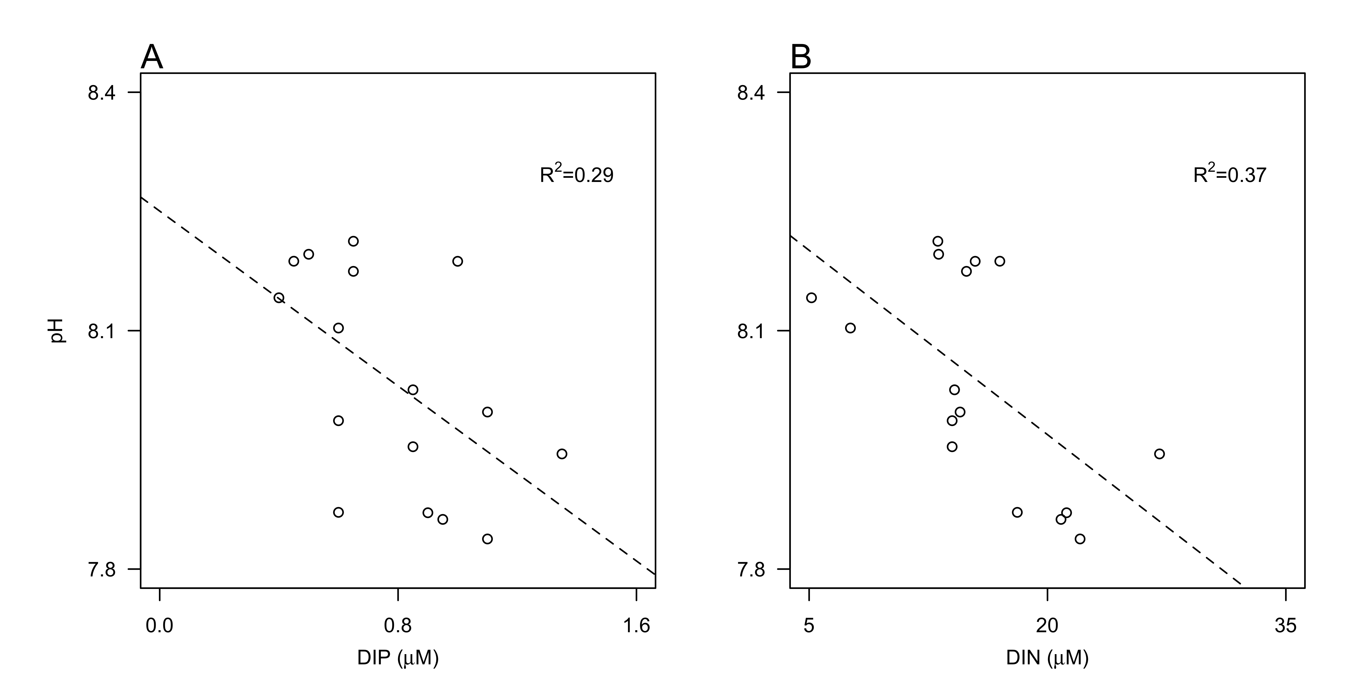

**Fig. S2** Relationship between pH and concentrations of A) dissolved inorganic phosphate (DIP, µM ), and ) dissolved inorganic nitrogen (DIN, as the sum of ammonium, nitrate and nitrite, µM). Dashed lines represent model II linear regression of plotted data and R2 represents the coefficient of determination.

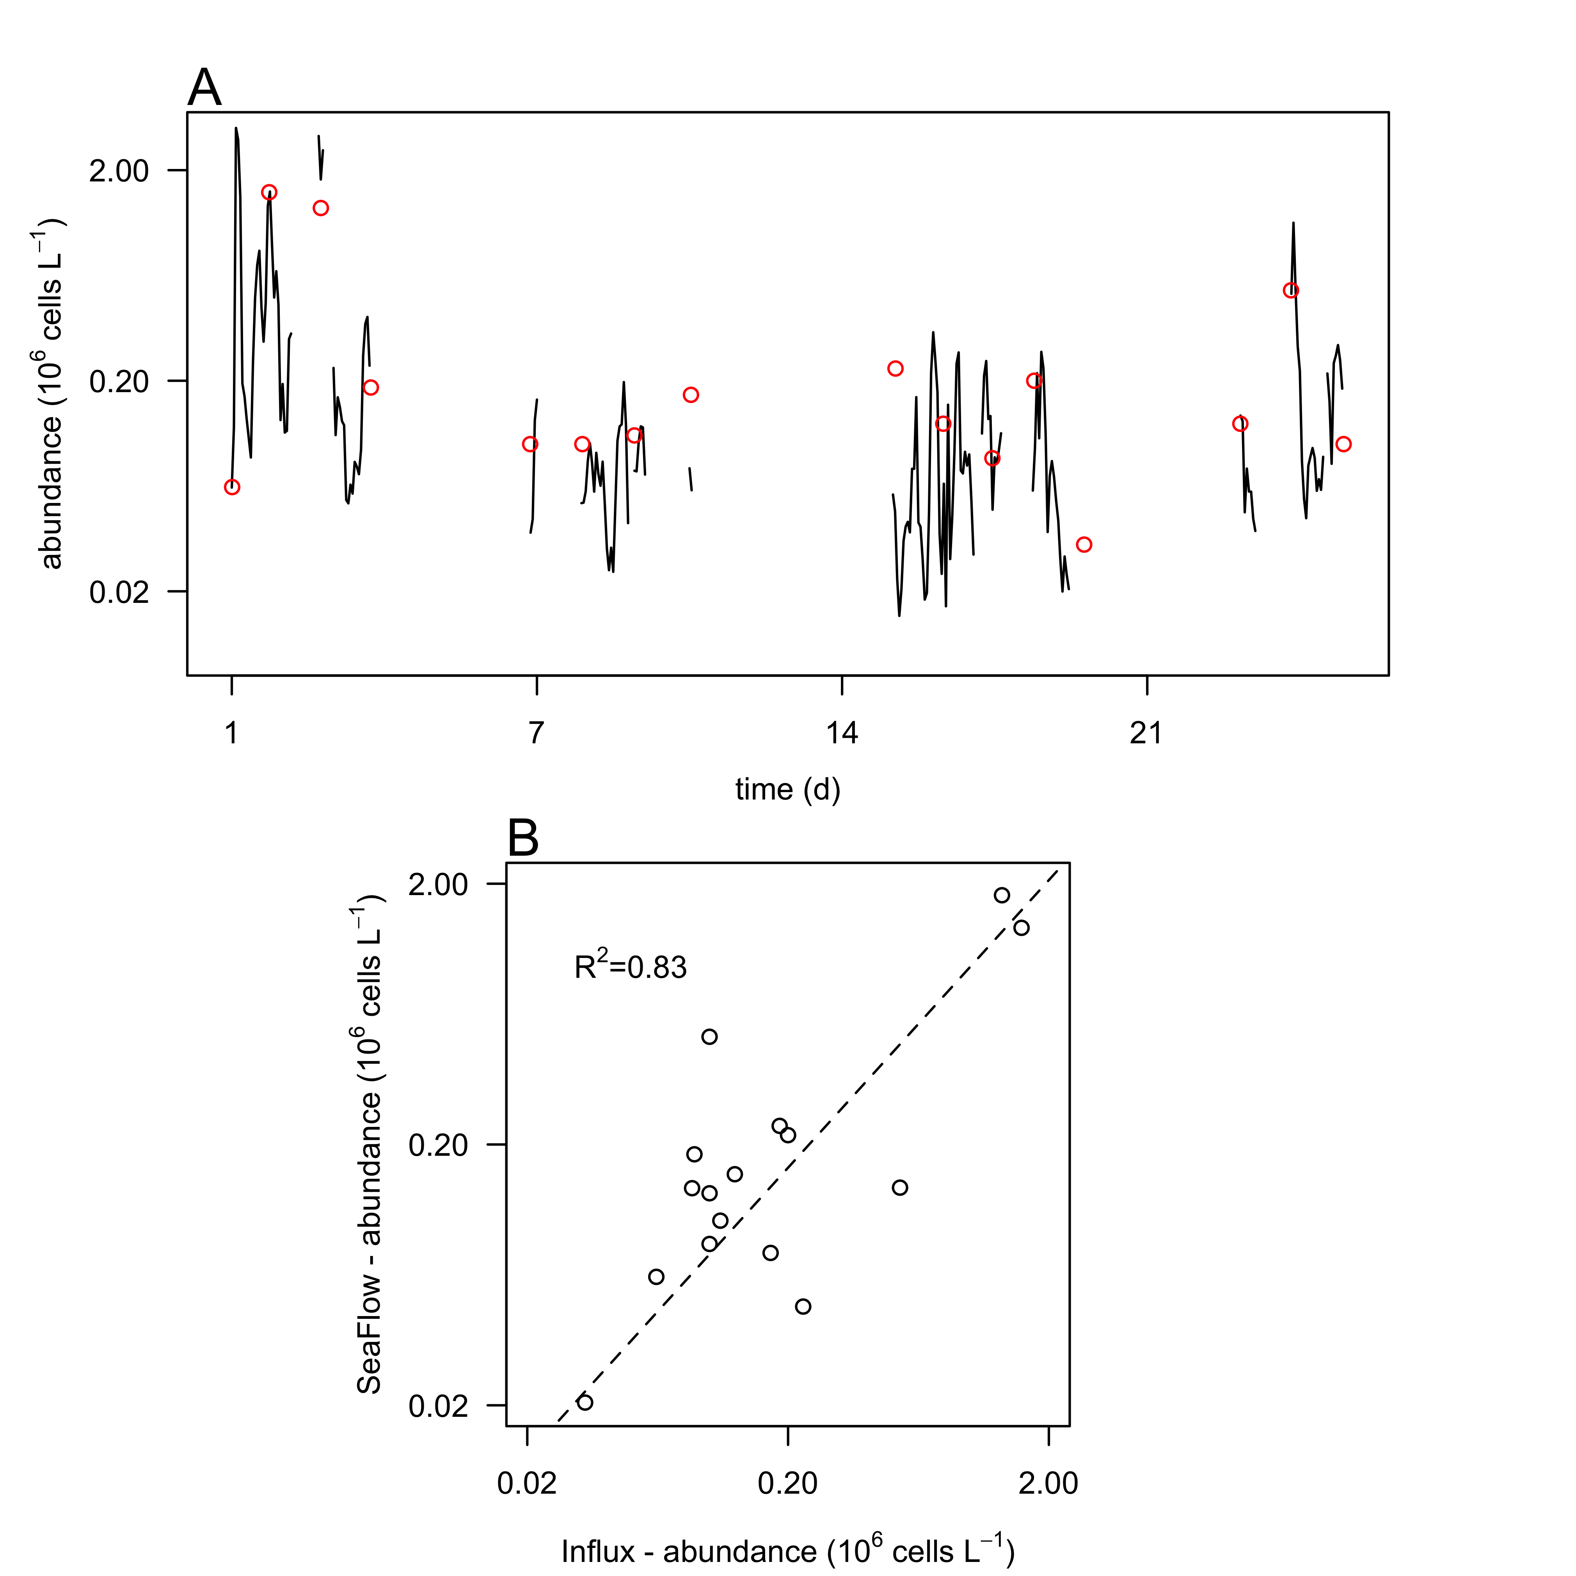

**Fig. S3.** Comparison of cell counts. A) Cell abundances of *Teleaulax amphioxeia* (106 cells L-1) during the survey measured with the SeaFlow instrument (black line) and measured with a BD Influx cell sorter (red circles). B) Correlation of cell abundances measured by the two instruments. Dashed lines represent model II linear regression of plotted data and R2 represents the coefficient of determination.

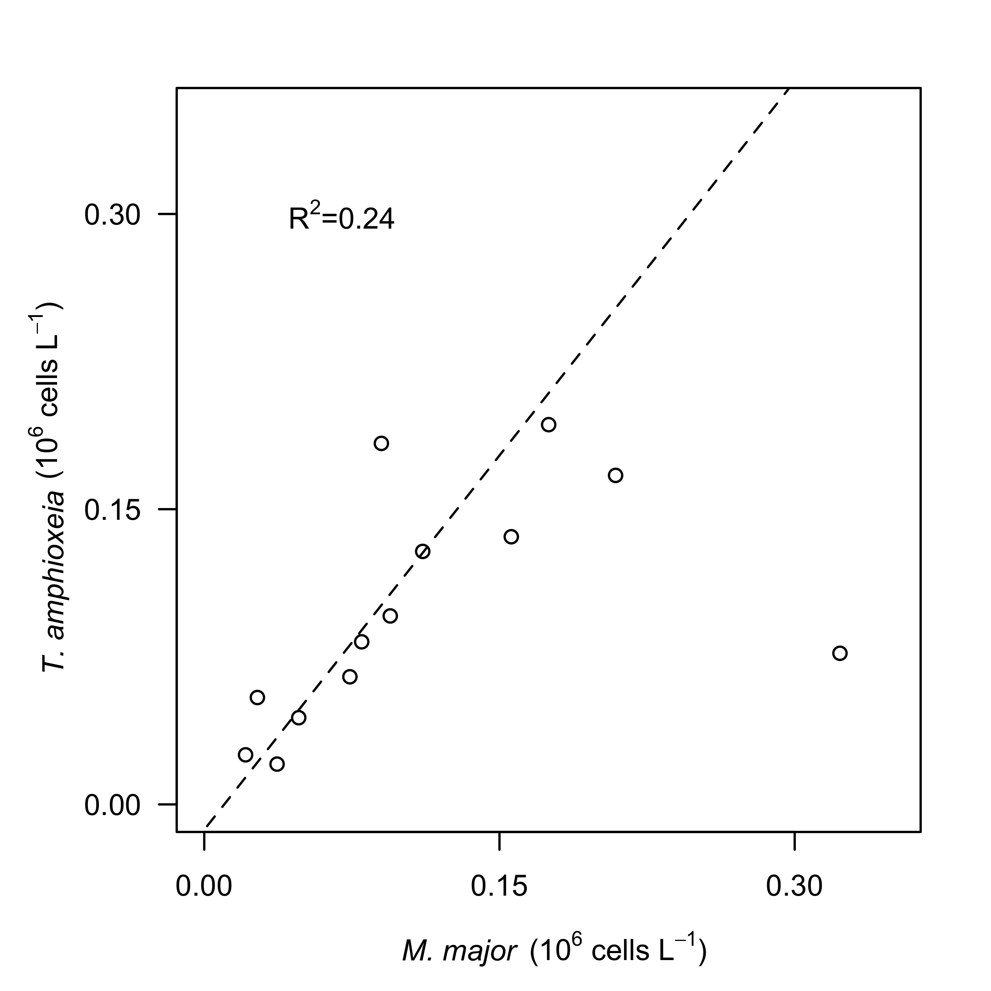

**Fig. S4** Relationship between hourly-average cell abundances of *Teleaulax amphioxeia* (*T. amphioxeia* 106 cells L-1)and abundances of *Mesodinium major* (*M. major*, 106 cells L-1) during the survey in the CRE. Dashed lines represent model II linear regression of plotted data and R2 represents the coefficient of determination.

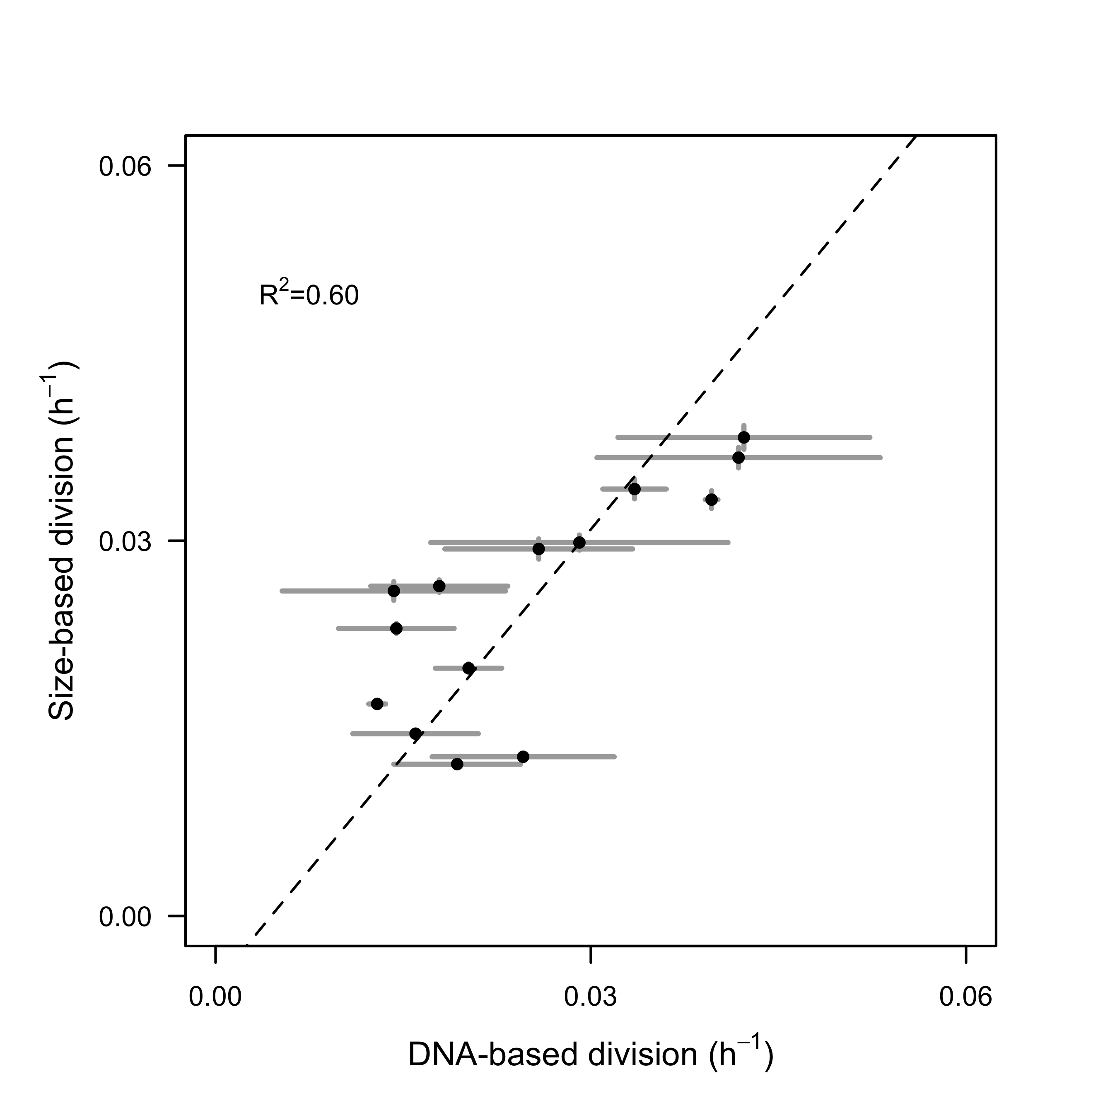

**Fig. S5.** Comparison of size-based division rate estimates (h-1) with DNA-based estimates of division rates (h-1) of *Rhodomonas* sp. in cultures over the course of 28-hr. Dashed lines represent model II linear regression of plotted data and R2 represents the coefficient of determination.

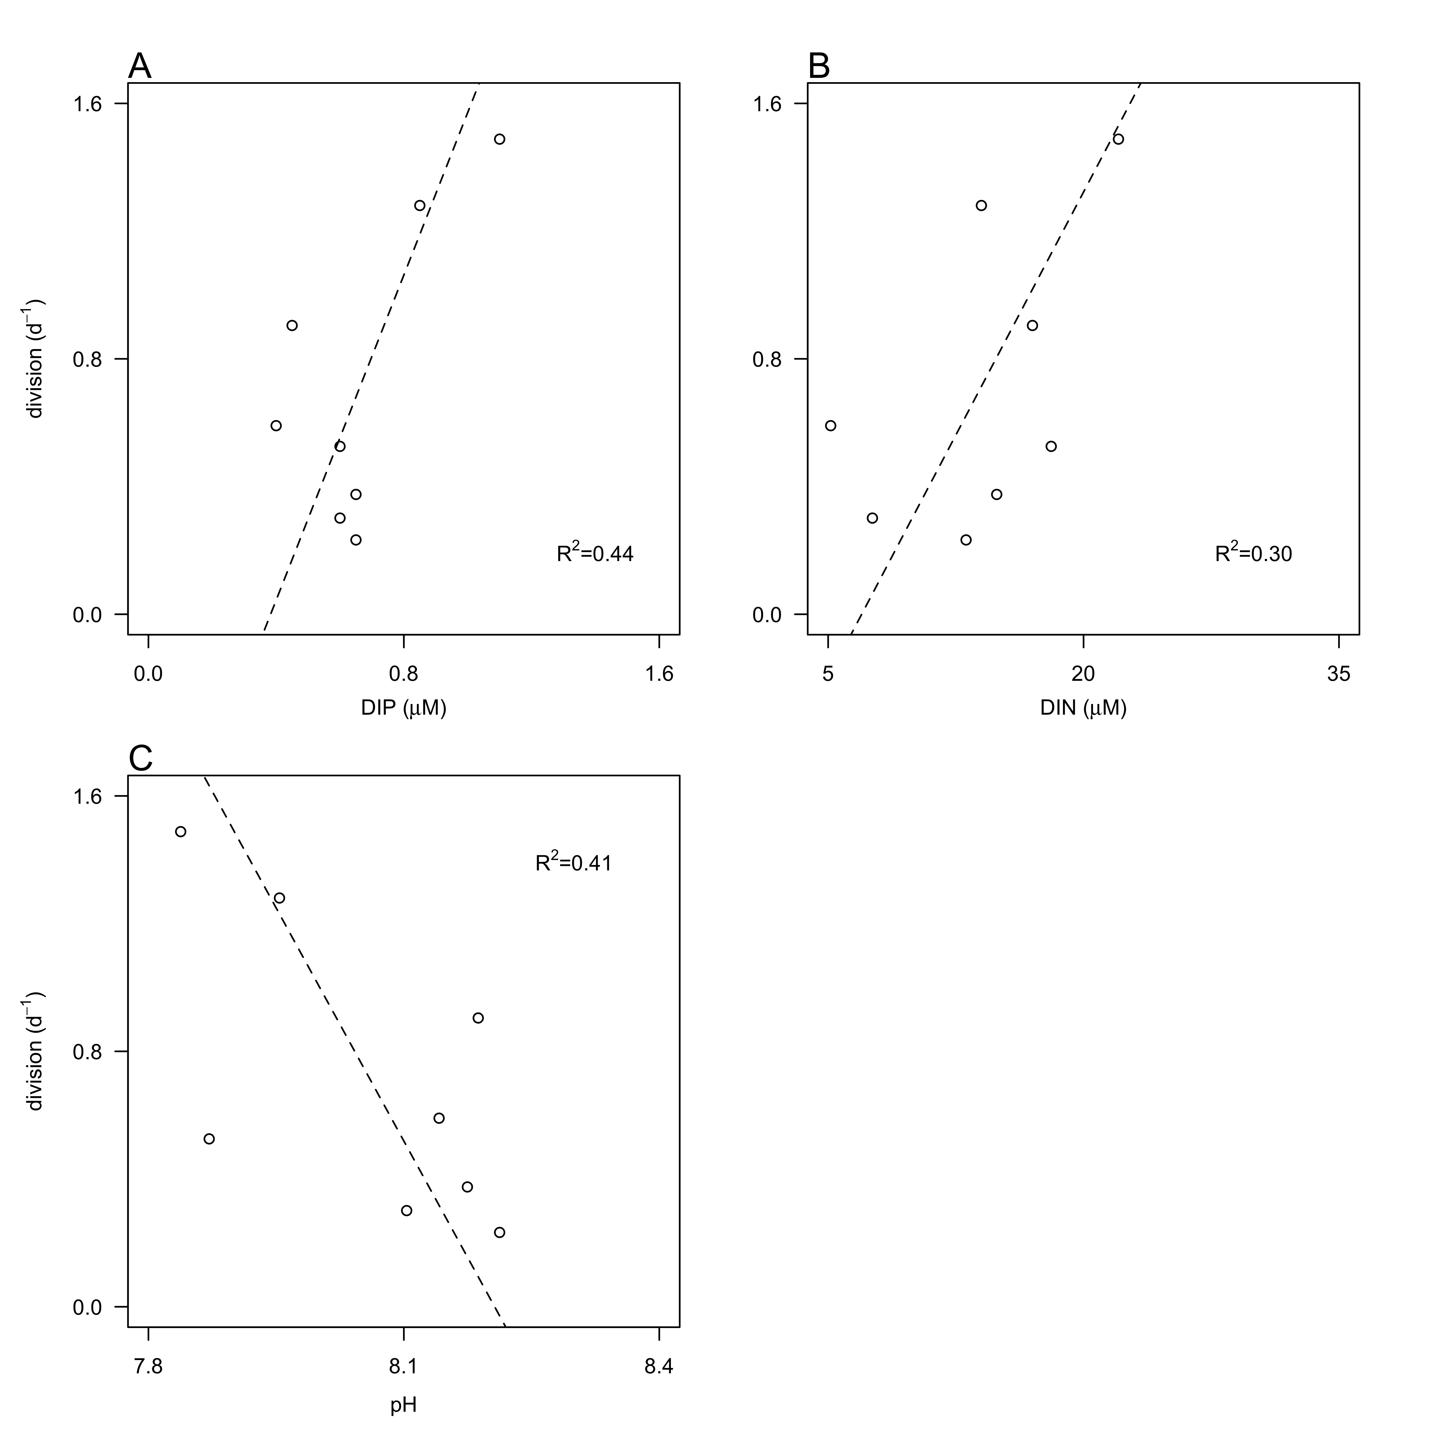

**Fig. S6** Relationship between division rates (d-1) of *Teleaulax amphioxeia* with daily-averaged concentrations of dissolved inorganic A) phosphate (DIN, µM) and B) nitrogen (DIN, µM) and pH during the survey. Dashed lines represent model II linear regression of plotted data and R2 represents the coefficient of determination.